1 Summerhill Parade
Sandycove
Co. Dublin
A96 T180

01 2937882
info@treehousepractice.ie
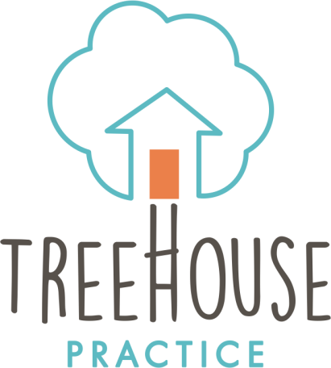

Information for Tusla referrers

Welcome to Treehouse Practice. We are a specialised multi-disciplinary team for young people who have experienced trauma and adversity in their lives, and the network of adults that support the young person. Treehouse Practice takes a relationship-based approach to assessment and intervention. This means that whilst it will be the young person’s name on the referral form, birth parents, foster carers and other key adults in the young person’s life will also be central to the process. This process is explained to parents and carers at the outset of our involvement but also requires consideration by Tusla as referral agent and agency with statutory responsibilities for the young person’s care.

As such, Treehouse Practice ask that you fully discuss this approach with the adults in the child’s life at the time of referral. From a practical point of view, this means letting parents and foster carers know about the following:

- Many assessment and therapy sessions at Treehouse Practice are recorded so that we can understand the nuances of relationships and so that we can use external coders who are ‘blind’ to the case to obtain objective views. The recorded aspects of the assessment are the Meaning of the Child Interview (with adults) and the Marshack Interaction Method assessment (with young person and adults together). For babies and toddlers, there is also a joint adult/ child recording, called the Infant or Toddler Care Index.
- There are also recorded assessment elements for the young person, including the Child Attachment and Play Assessment, the School Age Assessment of Attachment, the Transition to Adult Attachment Interview. The choice of this is dependent on the young person’s age
- Adults will be asked about their own experiences of being cared for and of providing care themselves. They will also be asked about their relationship with the particular young person referred to Treehouse Practice
- Treehouse Practice has relationships with external attachment coders and information will be shared with these professionals, with whom Treehouse Practice has contracts and agreements around professional standards, confidentiality and data sharing.
Treehouse Practice require signed consent forms from the young person’s social worker, parent and foster carers so that they are fully informed of these processes and have considered their willingness to take part.

Treehouse Practice further recognises that many families will have ongoing involvement with a legal/ court process. Reports produced by Treehouse Practice are written for therapeutic purposes, and not for court proceedings. Treehouse Practice recognises that reports will be used for this purpose from time to time, however. If this is the case, it is recommended that a consultation be arranged with the authors of the report to look at how best to protect the interest of the young person, their parents and foster carers/ residential team and how best to have the therapeutic information understood by those involved in the legal proceedings.

As the young person’s social worker, I have read and understood this information and I consent to the assessment proceeding on this basis.

________________________________
Name of child referred to Treehouse Practice

________________________________
Signature of social worker

________________________________
Social Worker’s printed name

________________________________
Date

